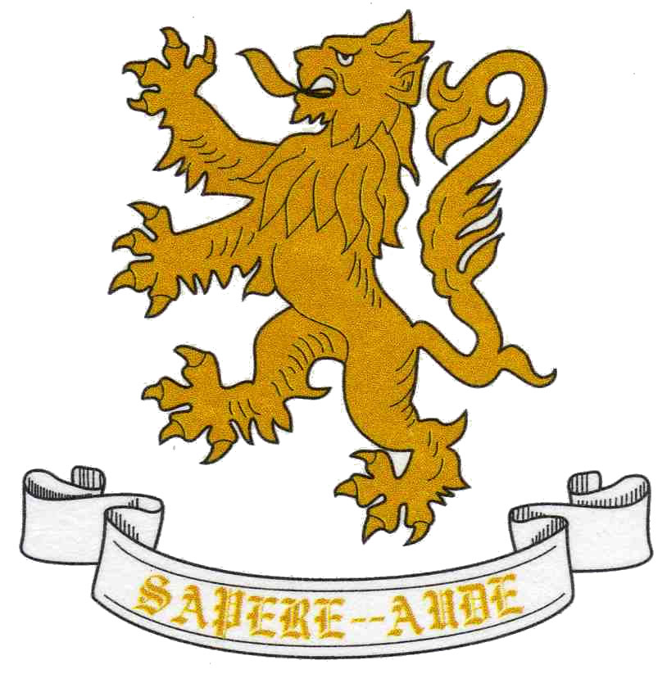
Crompton House PTFA presents its
'Lucky 13 Spring Ball'

Saturday the 2nd March 2019 - Where: The White Hart Inn, Lydgate

Start: 19.00 prompt - Carriages: 01.00 - Dress Code: Black Tie

RESERVATION DETAILS
If you wish to make a group booking you must nominate ONE member of your group as the contact person and complete this form with all the details of your party.
Name designated contact person (Please print)
E-mail address for communication (Please print)
Mobile number
The information you provide will be used by the PTFA solely for the purpose of administering the Spring Ball. Your information will be held by relevant members of the PTFA and confidentially destroyed when no longer required in connection with the Spring Ball. Please tick if you are happy for us to publish any photos taken on the night on the website or publicity material.

(It is important to pre-book the vegetarian option in advance )
 | Title | Forename | Surname | Vegetarian Meal  (Please tick)
1
2
3
4
5
6
7
8
9
10

Number of Tickets required at £45.00 per person ....... Total deposit £.........
Total Balance to pay before the 1st February 2019 £.............
Payment options | Tick

Please make cheques payable to Crompton House PTFA
Bank Transfer: Crompton House PTFA 20-64-12 10299340
Reservation Forms should be returned in an envelope marked

PTFA Spring Ball c/o Reception at Crompton House School and will be numbered on a first come first served basis or e-mailed to s.lawrence@cromptonhouse.org
- Early Booking Recommended –

