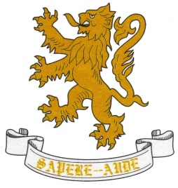
AUTUMN TERM
Department: Art  GCSE Art & Design | Year: 11
Unit/Topic: Portraiture |  | Hours allocated:  5 hours per fortnight
Overview of Unit/Topic
- Developing original ideas
- Experimenting, reviewing and refining
- Researching the work of relevant artists and designers
- Presenting an outcome

How will this unit be assessed?
GCSE coursework is assessed at least half termly and pupils are given ‘working at grades’.
There is a sheet in the back of each sketchbook which records short term targets and teacher advice.
Please see the back of sketchbooks for the course Assessment Objectives which will be used to assess the pupils at the end of the project. These fall under the following headings: Develop, Experiment, Record, Present.

.

SPRING TERM
Department: Art | Year: 11
Unit/Topic: Examination Unit |  | Hours allocated:  5 hours per fortnight
Overview of Unit/Topic

Examination Unit
Students are issued with the examination paper in January. They will prepare for an outcome which will be completed during two five hour sessions in March/April. They will be expected to use skills they have learned on their GCSE course.
How this work will be assessed:
GCSE coursework is assessed at least half termly and pupils are given ‘working at grades’.
Teachers will be able to advise pupils during the preparation period of the exam.
The examination will require students to work unaided.

SUMMER TERM
Department: Art | Year: 11
Unit/Topic: |  | Hours allocated:  5 hours per fortnight
Overview of Unit/Topic

The course will end at the end of April

