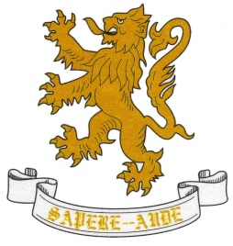
AUTUMN TERM
Department: Art  GCSE Illustration and Multimedia | Year: 11
Unit/Topic: Exam practice |  | Hours allocated:  5 hours per fortnight
Overview of Unit/Topic:
Students will be given a past exam paper and will work on a chosen question.

- To understand contextual and other sources linked to the question.
- Produce a mood board based on the theme.
- Produce two plans for photos based on your mood board.
- Fineliner and ink.
- Advanced Photoshop.
- DSLR camera.
- Lighting.
- Advanced printing techniques.
- Artist research.

Artists: J Paul Melegari, Me Company, Bradford Noble, James Porto.
How will this unit be assessed?

GCSE coursework is assessed at least half termly and pupils are given ‘working at grades’.
There is a sheet in the back of each sketchbook which records short term targets and teacher advice.
Please see the back of sketchbooks for the course Assessment Objectives which will be used to assess the pupils at the end of the project. These fall under the following headings: Develop, Experiment, Record, Present.

SPRING TERM
Department: Art  GCSE Illustration and Multimedia | Year: 11
Unit/Topic: Exam |  | Hours allocated:  5 hours per fortnight
- The pupils will respond to the externally set assignment (exam ) set by AQA

How will this unit be assessed?

There is a sheet in the back of each sketchbook which records short term targets and teacher advice.
Please see the back of sketchbooks for the course Assessment Objectives which will be used to assess the pupils for their GCSE. These fall under the following headings: Develop, Experiment, Record, Present.

SUMMER TERM
Department: Art  GCSE Illustration and Multimedia | Year: 11
Unit/Topic: Exam |  | Hours allocated:  5 hours per fortnight
Overview of Unit/Topic

Skills and Techniques
- The course finishes at the end of April
How will this unit be assessed?

