Crompton House CofE School COVID student contract
To help minimise the risk of passing on the coronavirus, I agree to follow the rules below. These are in addition to the normal school rules on behaviour.
Hygiene
On entering school, I will sanitise my hands.

I will wash my hands after arriving at school, as well as during breaks and lunchtimes.

I will follow the ‘catch it, bin it, kill it’ respiratory hygiene guidance.
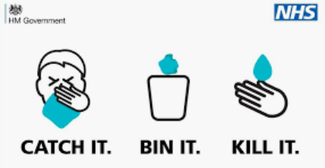

If I arrive at school wearing a face covering, I will not touch the front of my face covering when removing it. I will place my face covering in a plastic bag and take it home with me. I will wash my hands again before heading to my classroom.

Routines
On entering school grounds, I will go directly to my designated zone.
I will stay in my allocated zone before school, at break and lunch and will not intentionally mix with other student ‘bubbles.’
I will follow the one-way systems around school.
If I experience symptoms of coronavirus, I will tell an adult immediately.

I will bring in all the equipment I need for the school day.

I will label bottles of water and juice I bring to school.

I will follow the markings for queuing around the school.

I understand that I am expected to follow these rules for the health and safety of all students and staff at Crompton House. I also understand that if I do not follow these rules sanctions could include, but not be limited to, detentions and exclusions. Parents and carers will be contacted by Hub staff if the above rules are broken.
Student Signature: Form Group:

Print name:

