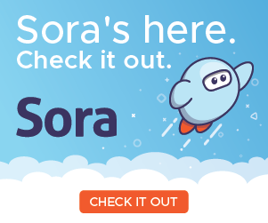
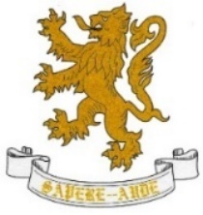

Crompton House School Library

Issue No25

Welcome to issue 25! November is here already, and the countdown to Christmas has begun. November is home to Anti Bullying Week this year’s theme is ‘United Against Bullying’ and so this edition includes book recommendations around this topic. November is also ‘Non-Fiction November’. This issue also includes informative websites and activities and competitions for all ages to enjoy together.

BOOK REVIEW

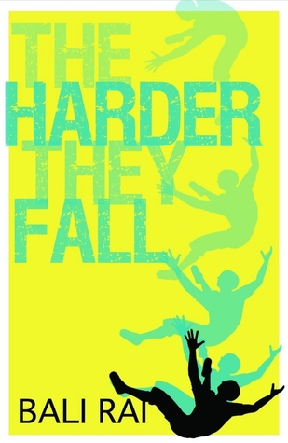

The Harder They Fall – Bali Rai
Bullying/School Life/Friendships/Poverty/Mental Health
Interest age 12-15
Cal's family are proud to live in an 'analogue' world - no WIFI in their house, just an ancient black-and-white TV. At school, Cal has no choice but to live in the 21st century, coping with a range of bullies and chancers on a daily basis. When Cal's mum decides to 'rebalance' the family with a stint as volunteers at a local foodbank, Cal inadvertently discovers new kid Jacob's secret, and Jacob flips
The author Bali Rai grew up in a deprived area of Leicester, a city which is almost unique in terms of cultural mix and his style of writing is firmly grounded in the reality that he has seen around him since he was a child. There are engaging messages in this short book that are necessary for young people it is a gripping and compassionate tale. It is written in a dyslexic friendly layout and published by Barrington Stoke. Bali Rai has written lots of books around the themes above.
N.B There are some mature themes and words in this book.

Anti-Bullying Week 2020 – ‘United Against Bullying’
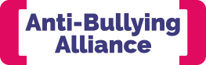
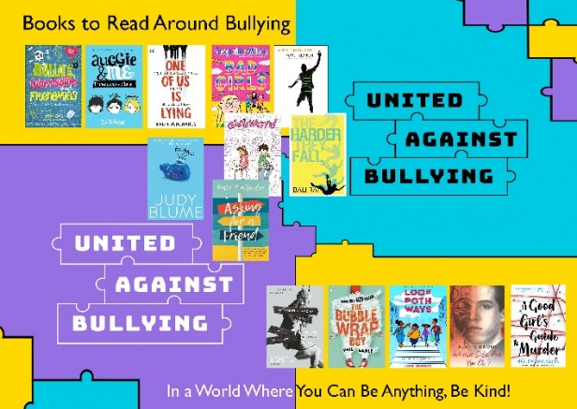
Anti-Bullying Week 2020 is happening from Monday 16th – Friday 20th November and this year the theme is ‘United Against Bullying’. It is coordinated by the Anti-Bullying Alliance, which is based at leading children’s charity the National Children’s Bureau. We have curated a collection of books in our school library based around these issues, some of them are detailed below but there are many more in the collection. Ask Mrs. Cullen for more information.

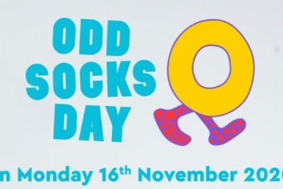
.

Great websites and Information

- The Anti Bullying Alliance supports the annual Anti Bullying Week awareness campaign and you kind find out more here.
- The Reading Agency developed the ‘Reading Well’ initiative which is a selection of books chosen by health officials helping young people to manage health and wellbeing including bullying. You can find out more about the titles here, but we do have some of these titles in the school library.
- Sora – CHS online E and Audio Book has a very good fiction and nonfiction collection titled Bibliotherapy where you can find lots of titles that help cope with difficult situations, take care of yourself and help empathise with others. There is also a Non-Fiction November section.
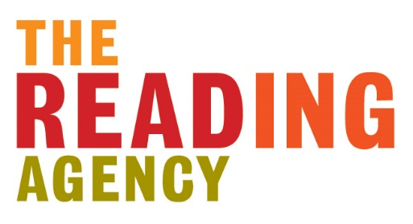
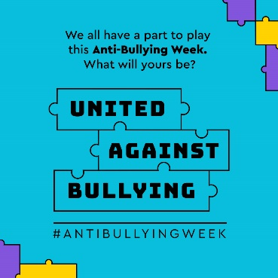
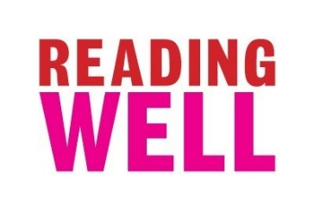
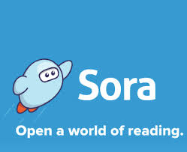

This Weeks Activity – United Against Bullying Competition
Poster - Create a poster for Crompton House School with an Anti-Bullying theme. The winner will have their poster produced on vinyl and displayed across the school to promote a CHS Anti Bullying Message.
Creative Words -Write up to 500 creative words around the theme ‘United Against Bullying’ The winner will be judged by the English Dept and will be published in the Stay in Touch Newsletter.
Closing date for entries is Friday 27th November.
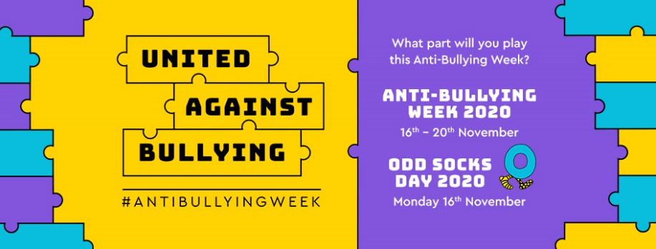

Share Your Creations with me - Mrs. Cullen!

If you would like to share a book review, activities, artistic creations or any other literacy related ideas, I would love to see them.
You can contact/tweet me and email reviews etc. on the details below. Happy reading.
If you are concerned about bullying, it is important you contact an adult, whether that is a parent, carer, teacher, form tutor or head of year in the school Hub.

For more information contact Mrs. Cullen - c.cullen@cromptonhouse.org
Twitter: @CLearningzone
