What to remember after a panic attack?

- Think about you: Think about yourself, pay attention to what your body needs after you’ve had an attack. For example, you might need some rest (if you’re in public play some calming music), you might need something to eat or drink.
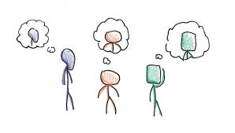

- Tell someone you trust: Talk to someone about how you felt/what brought it on. It is also useful to tell someone you trust how to spot when you’re having/going to have one so they can help you. If you don’t have anyone then you can turn to your journal.

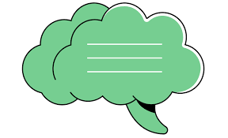

Why?
Panic attacks can take a lot of energy out of you so make sure you give yourself time to calm down and recharge, you should not expect yourself to go on about your day straight away. Listen to what your body is telling you. Doing Yoga or mindfulness can train you to help you understand your body and the messages that it gives us to tell us when it isn’t ok. When you know your bodies warning signs you can then take some action to help it.

Journaling can be helpful for any worries; journaling can help you disburse and make sense of worries to prevent a build up to leads to an anxiety attack. Journaling can also help you make sense of your attack as sometimes it’s not obvious what caused them to happen but if you write out what happened before, during and after you may find your reason. The more reasons you can find that cause your panic attack the better as you then know what to be aware of, what to avoid and what to work on to stop those things being a worry and building up your anxiety. It is also useful to reflect back on worries and panic attacks to identify what did and didn’t work for you that time so you can be prepared for next time and share this with someone you trust so they can help you better in the future

