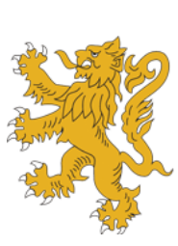
Revision Guidance: Preparation for Summative Assessment 1

Subject: | Art
Assessment Date: | Week Commencing: 14th December
Please revise the following topic areas: |  | Topic Revision Links
Drawing eyes accurately and in detail |  | How to Draw an Eye - Step by Step - YouTube
Drawing noses accurately and in detail |  | How to Draw a Nose - Step by Step - YouTube
Drawing mouths accurately and in detail |  | How to Draw Lips - Step by Step (youtube.com)
Understanding the position of the features of the face |  | How to Draw the Head - Front View (youtube.com)
Understanding how to use tone to make drawings look realistic |  | Painting the Planes of The Face Broken Down So You Can Understand (youtube.com)
Your artwork can show expression in a face |  | 🥺 HOW TO DRAW EMOTIONS?? (level 1-3)
Showing an understanding of an artist’s work in your own work |  | Looking at other artist's work
Using your chosen materials with care and control |  | Practice, practice, practice
Using colour, distortion and exaggeration to show a mood or feeling |  | Representing Mood Through Color  picasso distortion mood artwork - Google Search
Understanding how to improve your work to make progress |  | Bad Drawings Can Make Us Good
Presenting your work neatly and carefully |  | GCSE Art, A level Art. How to present artwork in a sketchbook #Art #GCSEArt

