
Revision Guidance: Preparation for Summative Assessment 2 Autumn 2024
Subject: | Y9 Science
Assessment information: | Week Commencing: 20/05/24  You will complete an exam paper with multiple choice questions and  some longer written questions.  There will be content from year 7, year 8 and year 9.
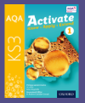
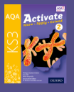
Textbook recommended found on Kerboodle (instructions below)
Please revise the following topic |  | Topic Revision/Links
Digestion |  | AQA Activate book 2 page 132 - 142  Nutrition, digestion and excretion - KS3 Biology - BBC Bitesize
Elements |  | AQA Activate book 2 page 68-77  Elements, compounds and mixtures - BBC Bitesize
Periodic table |  | AQA Activate book 2 page 78-87  Periodic table - KS3 Chemistry - BBC Bitesize
Energy | AQA Activate book 1 page 4  0-52  BBC bitesize  https://www.bbc.co.uk/bitesize/topics/zc3g87h/articles/zg2sn9q
Forces | AQA Activate book 1 page 14-22  BBC bitesize  https://www.bbc.co.uk/bitesize/topics/z4brd2p/articles/zs3896f
Graphs and line of best fit | AQA Activate book 1 page 8-9
Metals and non-metals | AQA Activate book 1 page 122-133  What are metals and non-metals on the periodic table? - BBC Bitesize
Particle model | AQA Activate book 1 page 76-93  BBC bitesize  Solids, liquids and gases  https://www.bbc.co.uk/bitesize/topics/z9r4jxs/articles/zqpv7p3  Change of state  https://www.bbc.co.uk/bitesize/topics/z9r4jxs/articles/zyhntrd  Gas pressure  https://www.bbc.co.uk/bitesize/topics/z9r4jxs/articles/zgh3ydm
Respiration and breathing | AQA Activate book 2 page 122-131 and 146-151  BBC bitesize  Structure and function of the gas exchange system  https://www.bbc.co.uk/bitesize/topics/zvrrd2p/articles/zk9t6g8  Respiration  https://www.bbc.co.uk/bitesize/topics/zvrrd2p/articles/zdqx2v4  Process of breathing  https://www.bbc.co.uk/bitesize/topics/zvrrd2p/articles/zbhcg7h  Anaerobic respiration  https://www.bbc.co.uk/bitesize/topics/zvrrd2p/articles/zcsbmsg  Lactic acid  https://www.bbc.co.uk/bitesize/topics/zvrrd2p/articles/ztdmrwx  The effect of asthma, smoking and exercise on the gas exchange  https://www.bbc.co.uk/bitesize/topics/zvrrd2p/articles/z3tb3j6
Working Scientifically | AQA Activate book 1 page 2-11  AQA Activate book 2 page 2-17  Working scientifically - KS3 Biology - BBC Bitesize

Accessing Kerboodle

Got to website https://www.kerboodle.com/users/login
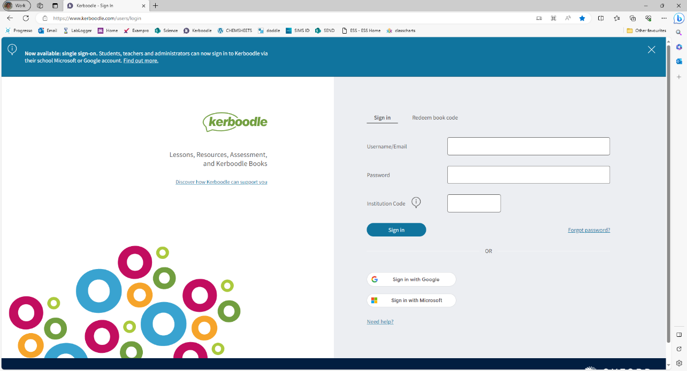

Click on sign in with Microsoft
Use school email and password to log in using Microsoft so for example if student called Jane Bloggs school email would be janebloggs@cromptonhouse.org password would be whatever password they use to sign into the computer with at school.
AQA Activate is the textbook that we have got in school and these are the page references above. There are other KS3 resources here too feel free to look at them all!
