Subject: | Computer Science
Assessment Date: | Before Easter – ask teacher for which lesson
Please revise the following topic areas: | Topic Revision Links
Data Representation
Binary, denary and adding binary numbers.  Image, sound, character representation | You will get one question based around  - Binary  - Denary  - Adding binary numbers  Use the link below to help you recap your knowledge.  Binary and denary - Units and data representation - OCR - GCSE Computer Science Revision - OCR - BBC Bitesize
Binary | 1 = On  0 = Off  You will need to remember the number sequence, starts at 1 and doubles. You will only be given a 8 digit (byte) number  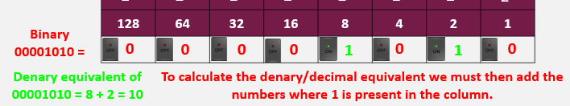  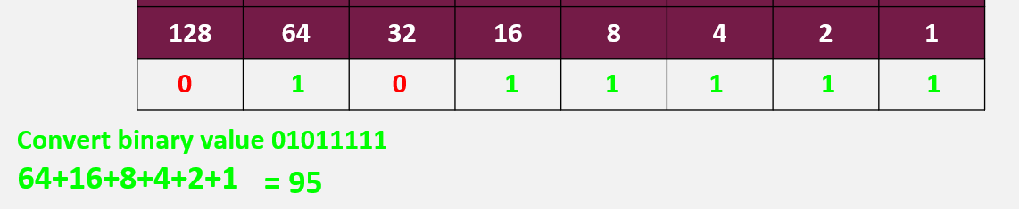
Denary to binary | To convert a denary/decimal number to a binary number, we use the column headings.  We ALWAYS start from the left, find the highest column heading that you can take away from the number and start there:  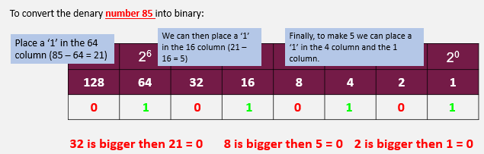  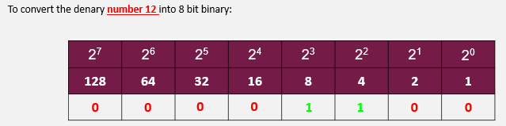  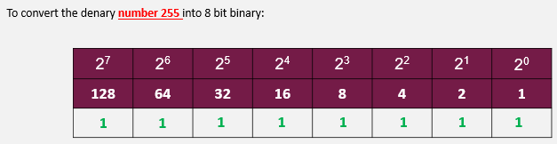  Cisco's Binary Number Game [Binary Blitz]. Penjee's adaptation.
Adding binary | 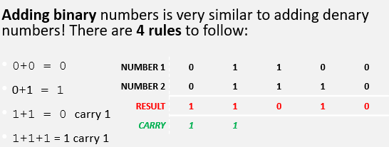
Task: Convert the following decimal numbers into binary and vice versa:

Convert 25 to binary.

Convert 101010 to decimal.

Add the binary numbers 1101 and 1011.

Answers:

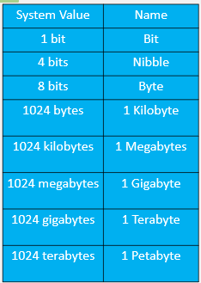
All data is stored in groups of bits.
Bit = (Binary Digit)
Bits can only store either 0 or

1 Bit = 0 (1 digit)

1 Nibble = 0000 (4 digits)

1 Byte = 01001100 (8 digits)
Image | Images are made up of pixels, and each pixel is represented by binary number.  Using one bit per pixel allows only 2 values, 0 and 1:  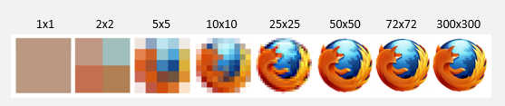  1 = Black, 0 = White.  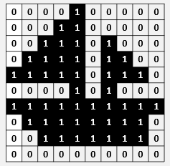  The more pixels the larger the image. As we add more bits per pixel, we increase the amount of colours available as each pixel is now storing more data.  1 bit can be represented by a 0 or a 1 and therefore is can offer 2 colours.  2 bits can be represented by 00, 01, 10, 11 and therefore offer 4 colours.  3 bits can be represented by 000, 001, 010, 011, 100, 101, 110, and 111. (8 colours)  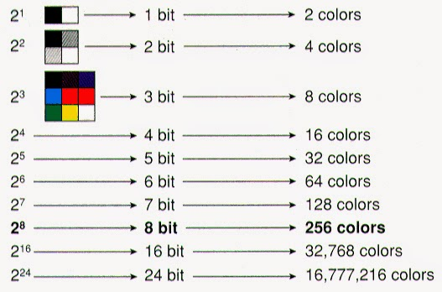  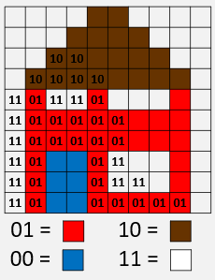
Image file type | JPEG, GIF, PNG, BMP, TGA, TIFF, HDR
Task: Describe how increasing the number of bits per pixel affects an image. Provide an example.

Answer:
Image resolution | Image resolution is the number of pixels within a specific area. This area is defined by the image width and height in pixels, e.g., 3268x2448.  DPI is the common unit (Dots per inch). Examples of resolution: 72DPI = screen resolution or 300DPI = print quality resolution.
ASCII | ASCII can represent characters 0-9, a-z, A-Z and a range or punctuation (,.;) and mathematical symbols (+ - / >)  Each ASCII character uses 8 bits and gives a maximum of 256 unique characters.  ASCII was created as humans find it difficult to write in 0s and 1s and needed a way to translate language to machine code. It is however limited to English and 256 different characters, limiting what it can convey.  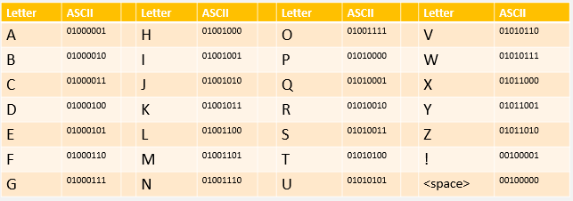
Unicode | Unicode was developed after realising the disadvantages of ASCII. It covers all of the languages that can be written in the following widely used scripts: Latin, Greek, Cyrillic, Armenian, Hebrew, Arabic, Syriac, Thaana, Devanagari, Bengali, Gurmukhi, Oriya, Tamil, Telugu, Kannada, Malayalam, Sinhala, Thai, Lao, Tibetan, Myanmar, Georgian, Hangul etc… It also includes emojis , mathematical symbols π and logos such as the copyright symbol ©  It supports over 1 million characters, providing a universal character encoding standard for digital representation of text across different platforms and languages.
Task: Compare ASCII and Unicode. Why is Unicode preferred?

Answer:
Sound | Analogue sound must be converted to digital and stored as binary values to be used on a computer.
Analogue to digital converter | Analogue sounds are translated to digital by capturing sound waves at regular intervals using a microphone and an analogue to digital converter.  Each sound wave sample measures the height of the sound wave, these are converted in binary and stored as a sound file.
Sample (sound) | Capture a sound wave at regular time intervals is known as a sample.  The higher the sample rate the closer the digital sound will be to the original = higher quality. The higher the sample rate, the larger the file size.  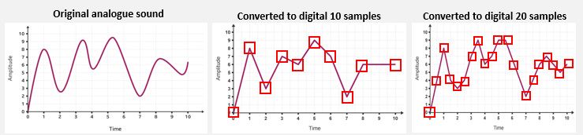
The more samples the higher the quality of sound and the larger the file size | 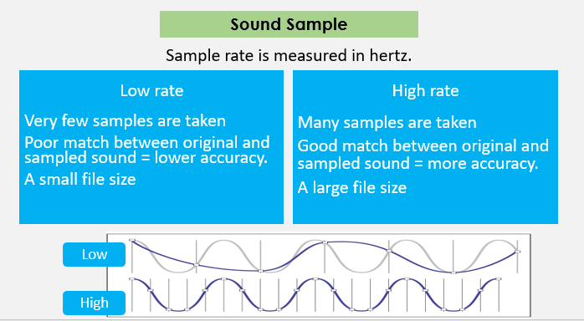
Bit depth | Bit Depth, which is the number of bits used to store each sample.  The higher the bit depth, the better quality the sound will be at each sample  A higher the bit depth means more data is stored in each sample, meaning a larger file size.  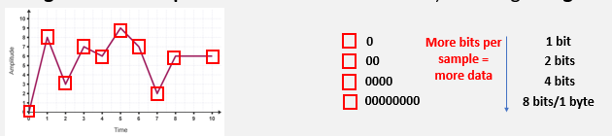
Task: Explain how sampling rate affects digital sound quality.

Answer:
Ai
Ai definition | A program or robot that is capable of self-learning and imitating human behavior.
Ai in Use | Facial and fingerprint recognition  AI is used to detect a face or fingerprint and give access to mobile devices.  Language processing  Siri, Alexa and Google Assistant are considered artificial intelligence. They take input from their environment and then make decisions about what information to present from their extensive databases based on that input.  Gaming – computer players  Making games more interactive, dynamic, and adaptive to players' skills and preferences.
Ai = data driven | Ai requires a vast amount to data to become a self – learning system. A simple data driven example could be Netflix or TicTok. It collects data on your viewing habits and uses this to recommend shows/videos of a similar nature.
Software = rule-based | Humans manually program rule-based systems such as software for ClassCharts, Sparx, word processing, presentations, spreadsheets etc…
Bias | Bias refers to a tendency to favour or dislike something, often unfairly, which can affect decisions or outcomes.
Algorithmic bias | Algorithmic bias occurs when algorithms make decisions that disadvantage certain groups of people. It can have disastrous consequences when applied to key areas such as healthcare, criminal justice, and finance.  Example: Due to the COVID-19 pandemic, A-Level exams were cancelled, and the UK government used an algorithm to assign grades based on students' predicted performance, historical school data, and mock exam results. However, the algorithm disproportionately downgraded students from disadvantaged backgrounds while favouring students from private schools.
Impact of Ai bias | A study published by the US Department of Commerce found…  AI misidentifies people of colour more often than white people. This finding raises concerns that, if used by law enforcement, facial recognition could increase the risk of the police unjustly arresting people of colour. In fact, wrongful arrests due to a mistaken match by facial recognition software have already occurred.  Example AI Bias in Self-Driving Cars: The Risk to Dark-Skinned Pedestrians  Self-driving cars rely on Ai systems, including computer vision and machine learning, to detect and respond to obstacles, including pedestrians. However, studies have found that these systems often perform worse at detecting people with darker skin tones, which raises serious safety concerns. If self-driving cars are deployed without addressing this bias, minority communities may face a higher risk of accidents and injuries.  Example of AI Bias Impact: The UK Met Police Facial Recognition System  The Metropolitan Police in London deployed live facial recognition (LFR) technology to identify potential suspects in public spaces. However, multiple studies and reports found that the system disproportionately misidentified Black and ethnic minority individuals, leading to wrongful stops and potential racial profiling.
Task: Give two examples of how AI is used in daily life and explain how it works.

Answer:
Machine Learning | Machine Learning is a type of technology that enables computers to learn and make decisions without being explicitly programmed. It involves giving computers the ability to improve their performance over time through experience and training data.
None bias training data | The quality and quantity of training data significantly impact the performance of AI models. Insufficient or biased training data can lead to poor model performance and biased predictions.  To reduce bias in AI systems, including self-driving cars and facial recognition, it's crucial to use non-biased training data. This means ensuring that datasets are diverse, representative, and fairly processed to avoid favouring any particular group.  That's why it's crucial to preprocess, augment, and carefully select the training data to ensure it's as representative and diverse as possible.
Supervised learning | Needs data that has been preprocessed by a human. Requires a lot of data to train.
Unsupervised learning | Clusters similar data together. Gives ideas on how to group the data.
Reinforcement learning | Learns by trial and error. Model needs time to get good at its tasks.
Image data | You are about to train your first machine learning model using images of apples.  Your data should include different types of apples, different colours, sizes, shapes and some damaged or bruised apples.  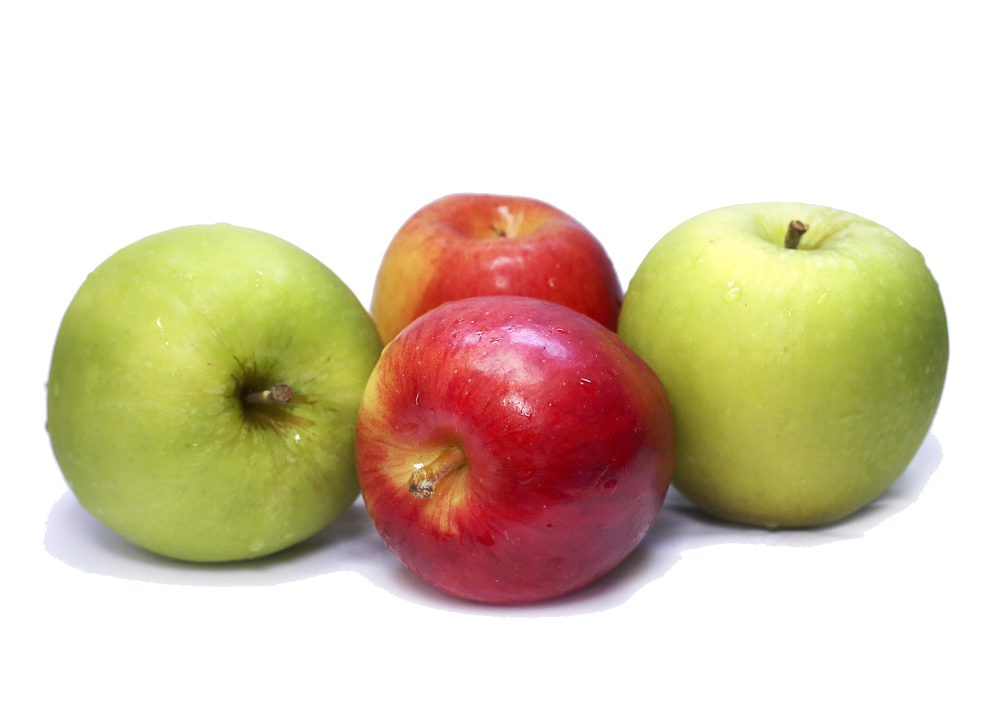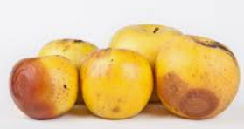
Task: Explain the difference between supervised, unsupervised, and reinforcement learning.

Answer:

Using computers Safely, Effectively and Responsibly
Caesar cipher | The Caesar cipher is one of the simplest and earliest known encryption techniques. It is a substitution cipher where each letter in the plaintext is shifted a certain number of places down or up the alphabet.  To encrypt the phrase "Crompton House" using the Caesar cipher with a 3-letter shift, each letter is shifted three positions down the alphabet. Here's how it would look:  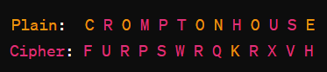  So, "Crompton House" encrypted with a Caesar cipher and a 3-letter shift becomes "Furpswrq Kruhv".  For example, with a shift of 3:  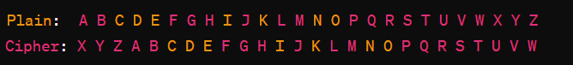
Encryption / Encrypt | Encryption is the process of converting plain, readable data (plaintext) into an unreadable format (ciphertext) using algorithms and keys. It's a fundamental technique used to protect sensitive information during transmission or while stored on electronic devices.
Decryption / Decrypt | Decryption, the reverse process of encryption, converts the ciphertext back into plaintext using the appropriate decryption key.
Task: Encrypt the word 'HELLO' using a Caesar Cipher with a shift of 4.

Answer:

The Enigma machine | The Enigma machine was invented by a German engineer named Arthur Scherbius in the early 1920s. It later became adapted by the German military and used extensively during world war II to encrypt military communications.  Unlike the Caesar Cipher which can be solved after the rotation has been found, the enigma machine used several rotors to give different results for the same letter.
Alan Turing | Alan Turing was one of the country’s best mathematicians, and worked at the top-secret intelligence base Bletchley Park, in Milton Keynes, just north of London.  He job was to try decrypt the enigmas code and save our navy and supply ships by intercepting and decoding military communications from Germany and decoding them.  Alan Turing - Celebrating the life of a genius (youtube.com)
Bletchley Park | Bletchley Park, located in Buckinghamshire, England, was the central site for British codebreakers during World War II. Its most famous achievement was breaking the German Enigma code, a feat that greatly contributed to the Allied victory in the war.  At Bletchley Park, mathematicians, linguists, and other experts worked tirelessly to decipher encrypted messages intercepted from German military and intelligence communications.  Maltesers | Companion (youtube.com)
Bombe Machine | After figuring out how to break the code, Alan Turing the developed the “Bombe” Machine to calculate the constant change for each letter, allowing the military to understand all communications.  The world officially found out about the Bombe machine after World War II, when the British government declassified information about Bletchley Park and its codebreaking efforts in the 1970s.
Task: Explain how Alan Turing and Bletchley Park contributed to breaking the Enigma code.

Answer:

CEOP | Child Exploitation and Online Protection –  How can CEOP help me? | young person  Specialise in supporting children and young people who are worried about sexual exploitation or grooming online.  If you make a report to CEOP about sexual abuse or grooming online it will be read by a Child Protection Advisors who will get in contact with you on the phone number or email address that you provide to make sure you are safe. They will also discuss with you what will happen next.  Never worry about reporting online sexual exploitation or grooming, you have done nothing wrong and CEOP will help you.
Trusted Adult | In situations of danger or discomfort encountered online, children and young people should seek assistance from a trusted adult such as a parent, guardian, teacher, or other responsible authority figure. Trusted adults can provide guidance, support, and help in navigating challenging online experiences, ensuring the safety and well-being of young individuals in the digital world.
Task: Why is it important to use a trusted adult or CEOP when encountering online dangers?

Answer:

Email | An electronic message sent over the internet from one person to another using a computer or mobile device.  It is a digital form of communication that allows individuals to exchange messages, documents, and media.
How emails work | Think of email servers as big, powerful computers that manage email. Each person has their own server, just like having their own post office.  Email servers have unique internet addresses, just like houses have unique street addresses. These addresses ensure that your email goes to the right server. (address).  Mail servers will then pass on or store emails until they are collected by its user, once they are logged in  Examples of mail providers are Outlook, Gmail or Yahoo Mail.
Sensible email name | Emails coming from cute, creative addresses are likely to be deleted immediately by future prospective employers.  Most people want to keep there email address long term so make sure you used a sensible name.  Email address are often requested to verify who you are, they will ask for an email address to send you an activation email.
To: | The address of user you’d like to message, this could be multiple people
CC: | Carbon Copy a person you are copying in, they do not need to action the email. The used in To: can see who has been copied in.
BCC: | Blind Carbon Copy – writing email address in here and the To: and CC: users cannot see who has been copied in.  Data Protection Act – if a teacher was sending an email to 20 parents, they will put their addresses in BCC so none of the parents could see each other emails, because the parent has agreed to share their information with the school but not with other parents.
Subject: | Brief over of the email content
Responding to an email | 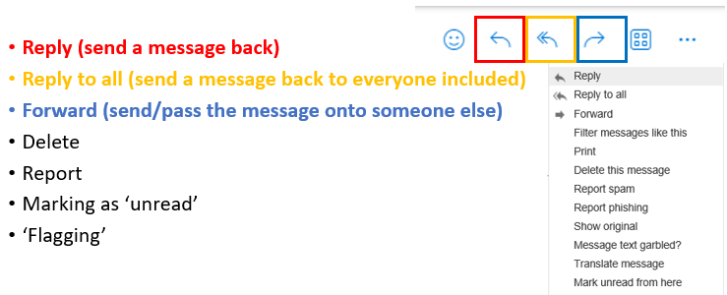
Attachment | When sending an attachment, the file is typically included with the email message but is not part of the message's body. Instead, it's a separate file that the recipient can download and view or interact with using the appropriate software.  To add and attachment we click on the paperclip image and select the file to upload.  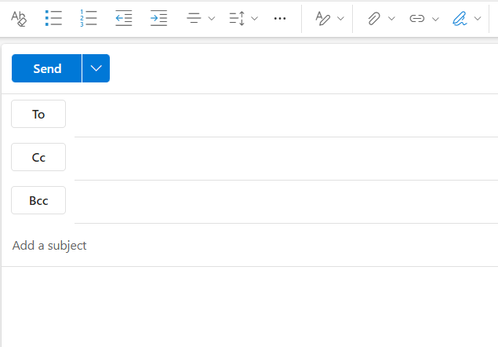
Task: Why should you use a professional email address for job applications?

Answer:

Shortcut keys | Copy = Control C  Paste = Control V  Undo = Control Z  Redo = Control Y  Cut = Control X  Save = Control S
File extension | All files have an extension. This indicates the type of software application that can be used to open them.  Portable document format = .pdf  PowerPoint presentations = .ppt  Word document = .docx  Spreadsheet = .xls  Images = .jpg .png .gif
File Explorer | File Explorer is a software application for managing your files, searching them, and navigating around them.  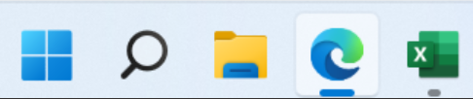
Cloud Storage via a Server | When we save our files, they are usually saved within our computer’s memory/storage.  Instead, we can choose to store data online and access this on different machines using the internet, this is known as cloud storage.  When data and files are sent to the cloud and saved online, they are being sent to a computer that provides large amounts of storage and is constantly connected to the internet.  This computer is called a server, it provides resources and services to its user.  Files can be uploaded and downloaded as required and use a folder system
Cloud Storage Advantage | - Data can easily be accessed from anywhere with an internet connection.  - The business running the cloud storage service manages backups and security.  - Additional storage can be added easily without having to invest in additional hardware.
Cloud Storage Disadvantage | - If you can access your data from anywhere with an internet connection, then a hacker can potentially do the same.  - If your internet connection fails, then you won’t be able to access your files.  - You are relying on other people to correctly secure your data and keep backups.  - You don’t know if employees of the cloud service will have access to your data.  - Apple could share and sell your data.
Task: List two advantages and two disadvantages of cloud storage.
Answer:

