Subject: | Computer Science
Assessment Date: | Teacher will provide the date
Please revise the following topic areas: | Topic Revision Links
Spreadsheet Modelling
Spreadsheet key vocabulary | Basic Spreadsheet Vocabulary (How To) | Spreadsheet Basics | Treehouse (teamtreehouse.com)
Spreadsheet terminology | This link is about giving you an overview of Excel (spreadsheets)  Excel Overview - Ribbon and Sheet
Absolute Cell Reference: | An absolute cell reference is when the cell does not change when it is copied to another formula. To make a cell reference absolute, you must include a $ before the reference (ex: $C$4)  Excel Absolute References
Active Cell | The active cell is the cell in the spreadsheet that is currently selected for data entry. The current active cell can be identified as being the one that has a darker border around it.
Cell Reference: | A cell reference is the name of the cell that is found by combining the Column Letter with the Row Number.  For example, the cell in Column "C" then Row "3" would be cell C3.  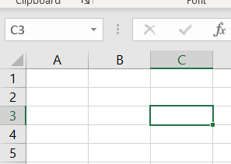
Cell formatting: | Cell formatting is used to make specific data easier to read, understand and stand out. You can do this by changing the colour of cells, changing different font or the alignment of text, adding information such as currency symbols or rearranging the data to be sorted into an order.  Excel Formatting
Columns | Columns are vertical. Column A is highlighted.  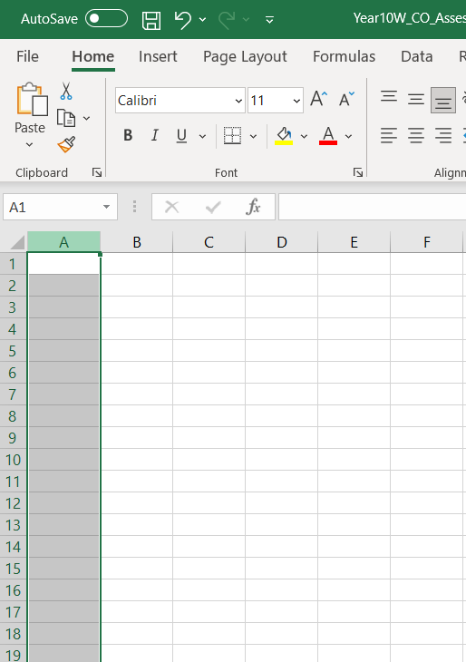
Data modelling | Data modelling is using your data to predict what might happen in specific situations and investigating the outcome. A what if scenario could be changing the prices or numbers of tickets to an event to reach a specific target
Data | Data refers to the type of information that can be stored in the cells of a spreadsheet. Spreadsheet data types include words, values (numbers), labels, formulas, and functions.
Fill Handle | The fill handle is the small bold square in the bottom right corner of a cell that can be used to copy (fill) data to adjacent cells in the same row or column. When you hover over the fill handle box, the mouse pointer will change to a black plus sign. You may then click the left mouse button, (and hold it down) while selecting the adjacent cells to copy to. Releasing the mouse button will then fill the content automatically.  Excel Fill
Formula | A formula is a spreadsheet data type that will calculate a result and display it in the active cell. A formula is written using cell references and must begin with an equal = sign.  An example of a formula would be: =A3+C3 which would take whatever value was entered into cell A3 and add it to the value that was typed into C3. After typing the formula and pressing the Enter key, the resulting value will be displayed.  Excel Addition Operator
Function | Functions are built-in formulas that are used to enter either commonly used or very complex formulas. Functions begin with an equal = sign and use cell references in their format.  One commonly used function is the SUM function, which will add up the values in a range. The function: =SUM(H2:H25) would add all values contained in cells H2 through H25 and return the result when the enter key is pressed.  Other function examples are  =SUM (add values in a range) Excel SUM Function  =AVERAGE (add up all the values in the column and divide by the number of values to find the average) Excel AVERAGE Function  = MAX (find the highest value in the column) Excel MAX Function  = MIN (find the lowest valued in the column) Excel MIN Function  Excel Functions
Gridlines | Gridlines are the horizontal and vertical lines on the screen that separate cells in a spreadsheet. Gridlines typically do not print unless the option is set in the layout options of the spreadsheet.  Excel Format Grids  Gridlines off  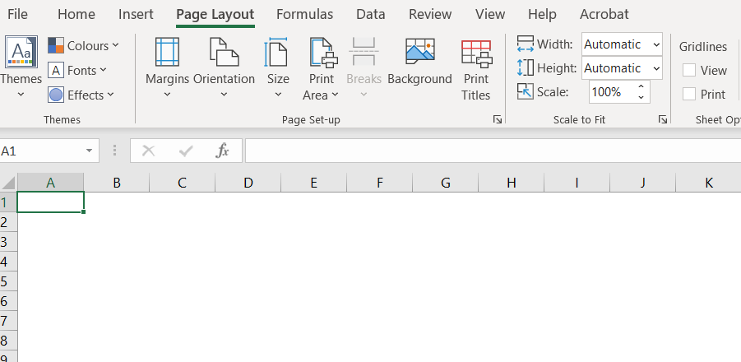  Gridlines on  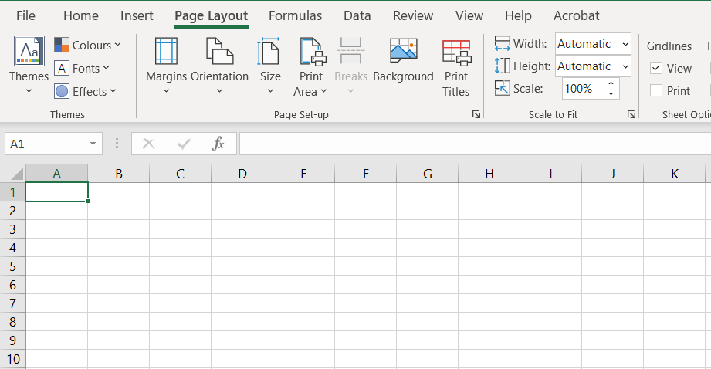
Range | A range is a group of cells in a spreadsheet that have been selected.  If the cells are all together in a rectangular or square shape, it is an adjacent range. An adjacent range is identified by the cell reference in the upper left and lower right corners of the selection separated by a colon.  Example: B1:B9  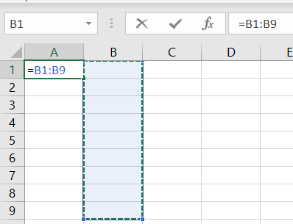
Relative Reference | A relative cell reference is one that changes when it is copied.  For example, if a formula that contains the cell reference "C4" is copied to the next cell to the right, the reference will change to D4 (updating the column letter).  If the same formula is copied down one cell, the reference will change to "C5" (updating the row number). The other type of reference is an Absolute Reference.  Excel Relative and Absolute References
Rows | Rows run horizontally on the spreadsheet screen. Row on is highlighted  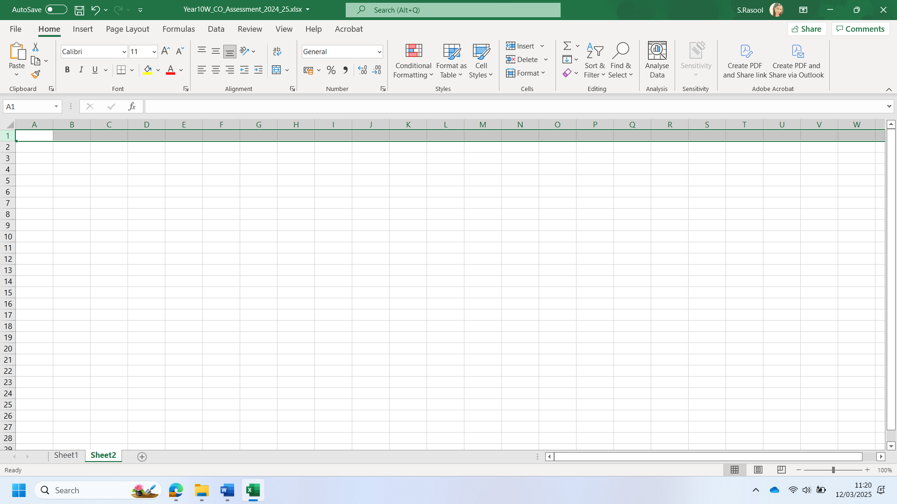
Sheet Tabs | In Microsoft Excel, the sheet tabs appear below the worksheet grid area and allow you to switch from one worksheet to another in a workbook.  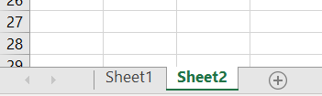
Workbook | A workbook is a collection of worksheets that are saved together in one file. Individual worksheets can be given descriptive names and you can switch from one worksheet to another by using the sheet tabs that appear beneath the worksheet grid area.
Worksheet | A worksheet is the grid of columns and rows that information is inputted into. In many spreadsheet applications (such as Microsoft Excel) one file -- called a workbook -- can contain several worksheets.
Learn Programming definitions
print () function | Allow information to be displayed to the screen  print (“Hello World”)
input() function | Captures information which is automatically save as a string with user input  name = input (“What is your name? “ )  favouriteColour = input (“What is your favourite colour? “ )
Variable | Stores a value in the location of memory
Data Types | Data types in python represent different types of values that can be stored and manipulated within a program. Four data types in python are:  Integer – integers are whole numbers.  Example: 5, 10, 25, 107. i.e. age, score, or ammo.  Age = 13  Float – floats represent decimal numbers.  Example: 3.14, 56.4, 192.3. i.e. currency, temperature, weight.  Height = 5.7  String – strings are sequences of characters, symbols, numbers, or letters and enclosed within speech marks.  Example Username, password, or email address. Student.User1, P@ssword2  Name = “Sam”  Boolean – Booleans represent one of two values: True or False. They are often used for logical operations and comparison.  Example:  If password = “Crompton”  login = True.
Sequence | One line of code run after another from line 1
Selection | If the condition is met, executing the command
Variable rules | Rules for variables:  Can’t start with a number  Can’t have gaps must use snake_casing or CamelCasing  Can’t used keywords that belong to python like print
Syntax error | Program will not run, due to grammar error. This could be a misspelling, punctuation, or code in the incorrect order.
Logic error | Program will run, but with an unexpected outcome. I.e. a calculation may work but not deliver the correct results due to a lack of BIDMAS applied.
Triple speech marks | print (“”” “””) allows code to be written over multiple lines and display data to the screen
What is the Python code doing?  Watch the videos 1 – 6  Fully explains the code. |   Python tutorial for beginners 🐍 - YouTube
Computer Crime and Cyber Security
A Trojan Horse | A Trojan Horse Virus is a type of malware that downloads onto a computer disguised as a legitimate program. The delivery method typically sees an attacker use social engineering to hide malicious code within legitimate software to try and gain users' system access with their software.  A simple way to answer the question "what is Trojan" is it is a type of malware that typically gets hidden as an attachment in an email or a free-to-download file, then transfers onto the user’s device. Once downloaded, the malicious code will execute the task the attacker designed it for, such as gain backdoor access to corporate systems, spy on users’ online activity, or steal sensitive data.  Indications of a Trojan being active on a device include unusual activity such as computer settings being changed unexpectedly.
Activity:
Imagine you receive an email from a friend with an attachment labelled "important_documents.zip". You are instructed to open it immediately. What steps should you take before opening this attachment to make sure it's safe?

Answer:
Adware | Adware, also known as advertisement-supported software, generates revenue for its developers by automatically generating adverts on your screen, usually within a web browser. Adware is typically created for computers but can also be found on mobile devices. Some forms of adware are highly manipulative and create an open door for malicious programs.  Adware is software that displays unwanted (and sometimes irritating) pop-up adverts which can appear on your computer or mobile device. Adware typically ends up on a user’s device through one of two ways:  You might install a free computer program or app without necessarily realizing that it contains additional software that contains adware. This allows the app developer to make money but means you could download adware onto your systems without necessarily consenting.  Alternatively, there may be a vulnerability in your software or operating system which hackers exploit to insert malware, including some types of adware, into your system
Activity:
You notice that every time you open your web browser, pop-up ads appear on your screen. What steps can you take to remove adware from your computer?

Answer:
Spyware | Spyware is a type of malicious software -- or malware -- that is installed on a computing device without the end user's knowledge. It invades the device, steals sensitive information and internet usage data, and relays it to advertisers, data firms or external users.  Any software can be classified as spyware if it is downloaded without the user's authorization. Spyware is controversial because, even when it is installed for relatively innocuous reasons, it can violate the end user's privacy and has the potential to be abused.  Spyware is one of the most common threats to internet users. Once installed, it monitors internet activity, tracks login credentials and spies on sensitive information. The primary goal of spyware is usually to obtain credit card numbers, banking information and passwords.  But spyware can also be used to track a person's location, as is the case with stalkerware. Often installed secretly on mobile phones by jealous spouses, ex-partners and even concerned parents, this type of spyware can track the physical location of the victim, intercept their emails and texts, eavesdrop on their phone calls and record conversations, and access personal data, such as photos and videos.
Activity:
You suspect your device has spyware installed because your internet connection is slower than usual, and you notice unfamiliar programs running. How can you check for spyware?

Answer:
White hat hackers | White hat hackers are also skilled at breaking into networks and exposing vulnerabilities in the computer systems of major retailers, government agencies, healthcare providers, and corporations. But these hackers use their powers for good rather than evil. Also known as “ethical hackers,” white hat hackers can be paid employees or contractors working for companies as security specialists that attempt to find security holes via hacking that companies can then correct.
Activity:
Imagine a company hires a security expert to test their website’s security. What might the white hat hacker do to improve the company’s security?

Answer:
Black hat hackers | Black hat hackers are the ones behind those big data breaches that make headlines each year. In a data breach, hackers steal personal and financial information held by large companies or governments, including the credit card, log-in and contact information such as phone number, address, age and medical records of consumers, patients or constituents.  These hackers can then publish this information to embarrass a corporation or government body, sell it on the deep web, or blackmail companies, agencies, or individuals.
Activity:
A major retailer experiences a data breach where millions of customer details, including credit card information, are stolen. What might black hat hackers do with this stolen data?

Answer:
Grey hat hackers | Gray hat hackers operate somewhere between the extremes of their black hat and white hat counterparts. They don't necessarily want to cause pain or steal from their victims, but they often hack into their targets' networks to look for vulnerabilities in a system without the owners' permission or knowledge.  If they find these vulnerabilities, grey hat hackers will report them to the owner, but they often request a fee to fix the issues they find. If the owner does not respond or comply, sometimes these hackers will post the newly found vulnerability online for the world to see.  These types of hackers may not be inherently malicious; they’re just looking to get something out of their discoveries. Usually, gray hat hackers will not exploit the vulnerabilities they find and may do it purely for moral values. However, this type of hacking is still considered illegal because the hackers don't receive permission from the owners before attempting to attack their systems.
Activity:
A hacker finds a vulnerability in a popular online banking system and reports it to the bank, but demands a fee to fix the issue. What are the legal and ethical issues involved here?

Answer:
Plagiarism | Plagiarism means copying someone else’s work and presenting it as your own. This could be ideas, words, images, music etc.
Activity:
You are writing a report for school and find a well-written article online that you want to use. What should you do to avoid plagiarism?

Answer:
Copyright – 70 years | Copyright laws protect the owners of creative works from having it copied and used without permission for 70 years. The symbol for copyright is usually before the owner’s name and emphasize the work is protected, but it does not need this symbol to be protected.
Permissions | Public domain – if the work is in the public domain, it means copyright has expired or the copyright has explicitly given up their rights.  Creative Commons Licenses – some creators choose to share their work with certain permissions.  Permission from the creator – the safest way to use someone’s work is to task for permission. If the creator gives the go ahead, you can use the work as per conditions agreed.
Activity:
You want to use an image you found online for your school project. What should you do to ensure you’re respecting copyright laws?

Answer:
Software Licensing | As with stealing content, we can also steal software with incorrect licenses used and not meant for their purpose. Software usually has 3 basic licensing types:  Single user – a single user is the most common type of software license. It allows one copy of the software on a single computer.  Multi-user license – these are used by larger users such as schools or companies that require several or many copies to run on a network.  Site license – a site license allows the company to have as many copies as they like within the same geographical location/building.  This is particularly useful for school, colleges or universities where license requirements may change year after year.
Activity:
You’re part of a small business, and you need to install a software package for your team. What type of software license should you choose if you want multiple users to have access to it?

Answer:
E-waste | Technology is created using a variety of resources, some of which are dangerous and require precious metals such as gold, silver, and platinum which have limited supplies. As we swap our devices for new improved versions, this creates a large amount of electronic waste that is shipped across the world. This e-waste is then recycled, with the recovery of precious resources done in dangerous conditions that significantly impact the health of those undertaking it.
Activity:
You want to recycle your old mobile phone, but you’re concerned about the environmental impact of e-waste. What should you do to ensure you’re recycling responsibly?

Answer:
Data Representation
Binary, denary and adding binary numbers.  Image, sound, character representation | You will get one question based around  - Binary  - Denary  - Adding binary numbers  Use the link below to help you recap your knowledge.  Binary and denary - Units and data representation - OCR - GCSE Computer Science Revision - OCR - BBC Bitesize
Binary | 1 = On  0 = Off  You will need to remember the number sequence, starts at 1 and doubles. You will only be given a 8 digit (byte) number  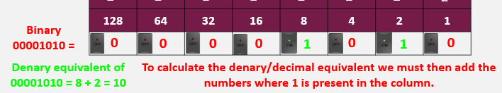  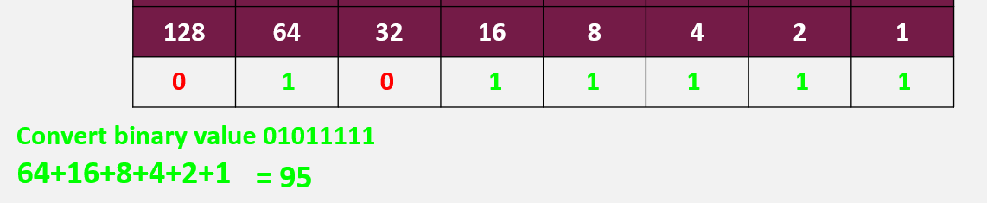
Denary to binary | To convert a denary/decimal number to a binary number, we use the column headings.  We ALWAYS start from the left, find the highest column heading that you can take away from the number and start there:  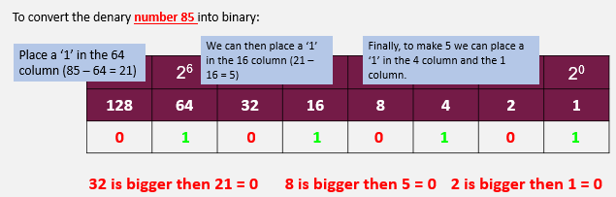  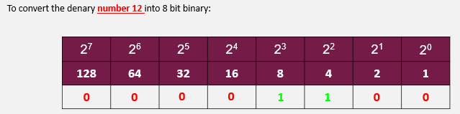  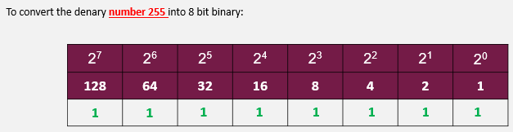  Cisco's Binary Number Game [Binary Blitz]. Penjee's adaptation.
Adding binary | 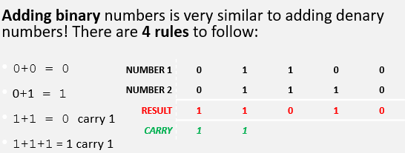
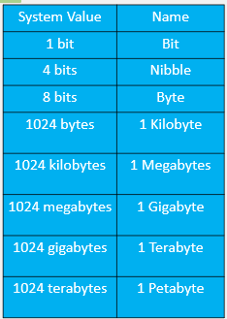
All data is stored in groups of bits.
Bit = (Binary Digit)
Bits can only store either 0 or

1 Bit = 0 (1 digit)

1 Nibble = 0000 (4 digits)

1 Byte = 01001100 (8 digits)
Image | Images are made up of pixels, and each pixel is represented by binary number.  Using one bit per pixel allows only 2 values, 0 and 1:  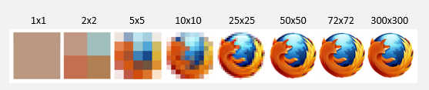  1 = Black, 0 = White.  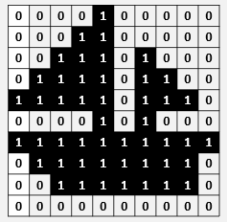  The more pixels the larger the image. As we add more bits per pixel, we increase the amount of colours available as each pixel is now storing more data.  1 bit can be represented by a 0 or a 1 and therefore is can offer 2 colours.  2 bits can be represented by 00, 01, 10, 11 and therefore offer 4 colours.  3 bits can be represented by 000, 001, 010, 011, 100, 101, 110, and 111. (8 colours)  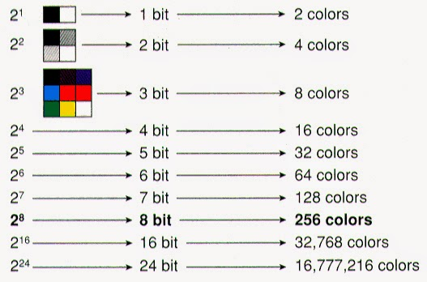  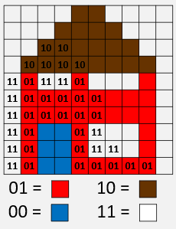
Image file type | JPEG, GIF, PNG, BMP, TGA, TIFF, HDR
Image resolution | Image resolution is the number of pixels within a specific area. This area is defined by the image size is represented using the width and height in pixels, e.g., 3268x2448.  DPI is the common unit (Dots per inch). Examples of resolution: 72DPI = screen resolution or 300DPI = print quality resolution.
Colour depth | Colour depth, also known as bit depth, refers to the number of bits used to represent the colour of a single pixel in an image or display. It determines the range of colours that can be displayed and the level of detail in the image's colour information.  For example:  8-bit colour depth: Can represent 256 colours.  16-bit colour depth: Can represent 65,536 colours.  24-bit colour depth (True Colour): Can represent approximately 16.7 million colours.  The higher the bit depth, the greater the potential for more colours and smoother gradients in the image.
ASCII | ASCII can represent characters 0-9, a-z, A-Z and a range or punctuation (,.;) and mathematical symbols (+ - / >)  Each ASCII character uses 8 bits and gives a maximum of 256 unique characters.  ASCII was created as humans find it difficult to write in 0s and 1s and needed a way to translate language to machine code. It is however limited to English and 256 different characters, limiting what it can convey.  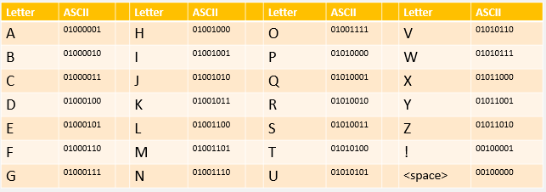
Unicode | Unicode was developed after realising the disadvantages of ASCII. It covers all of the languages that can be written in the following widely used scripts: Latin, Greek, Cyrillic, Armenian, Hebrew, Arabic, Syriac, Thaana, Devanagari, Bengali, Gurmukhi, Oriya, Tamil, Telugu, Kannada, Malayalam, Sinhala, Thai, Lao, Tibetan, Myanmar, Georgian, Hangul etc… It also includes emojis , mathematical symbols π and logos such as the copyright symbol ©  It supports over 1 million characters, providing a universal character encoding standard for digital representation of text across different platforms and languages.
Sound | Analogue sound must be converted to digital and stored as binary values to be used on a computer.
Analogue to digital converter | Analogue sounds are translated to digital by capturing sound waves at regular intervals using a microphone and an analogue to digital converter.  Each sound wave sample measures the height of the sound wave, these are converted in binary and stored as a sound file.
Sample (sound) | Capture a sound wave at regular time intervals is known as a sample.  The higher the sample rate the closer the digital sound will be to the original = higher quality. The higher the sample rate, the larger the file size.  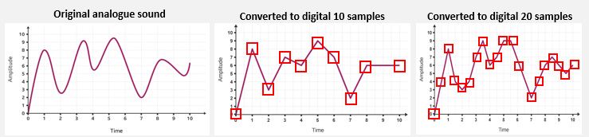
The more samples the higher the quality of sound and the larger the file size | 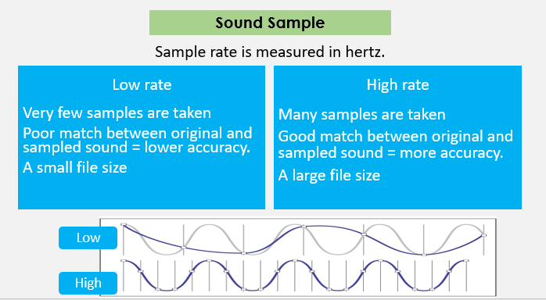
Bit depth | Bit Depth, which is the number of bits used to store each sample.  The higher the bit depth, the better quality the sound will be at each sample  A higher the bit depth means more data is stored in each sample, meaning a larger file size.  